A

PROJECT REPORT

ON

**ATMOSALERT**

Submitted in partial fulfilment of the requirements

of the degree of

**BACHELOR OF ENGINEERING**

**IN**

**COMPUTER ENGINEERING**

by

Shweta Shimpi (2022016402278264)

Ninad Walke (2022016402278063)

Aarya Walve (2022016402277953)

Guide:

Prof. Vedika Patil



**Department of Computer Engineering**

K.C. College of Engineering and Management Studies And

Research, Thane (E)

University of Mumbai

2024-25

**CERTIFICATE**

This is to certify that the project entitled **“AtmosAlert”** is a bonafide work of “**Shweta Shimpi(B-26), Ninad Walke(B-38), Aarya Walve(B-39)** submitted to the University of Mumbai in partial fulfilment ofthe requirement for the award of the degree of **“Bachelor of Engineering”** in **“Computer Engineering”**.

Prof. Vedika Patil

Guide



Dr. Nita Patil Dr.Vilas Nitnaware

Head of Department Principal

**Project Report Approval for T.E.**

This project report entitled (***ATMOSALERT***) by (***Shweta Shimpi(B-26), Ninad Walke(B-38), Aarya Walve(B-39)*** is approved for the degree of Bachelor of Engineering in **Computer Engineering.**

Examiners

1.....................................................................

(Internal Examiner Name & sign)

2.....................................................................

(External Examiner name & sign)

Date:

Place:

**DECLARATION**

We declare that this written submission represents our ideas in our own words and where others' ideas or words have been included, we have adequately cited and referenced the original sources. We also declare that we have adhered to all principles of academic honesty and integrity and have not misrepresented or fabricated or falsified any idea/data/fact/source in our submission. We understand that any violation of the above will be cause for disciplinary action by the Institute and can also evoke penal action from the sources which have thus not been properly cited or from whom proper permission has not been taken when needed.

_________________________

Signature

_______________________

[Shweta Shimpi (2022016402278264) 26]

[Ninad Walke (2022016402278063) 38]

[Aarya Walve (2022016402277953) 39]

`

Date:

**ACKNOWLEDGEMENT**

We would like to express special thanks of gratitude to our guide **Prof. Vedika Patil** guide gave us the golden opportunity to do this wonderful project on the topic of **ATMOSALERT**, which also helped us in doing a lot of research and we came to know about so many new things. We are very grateful to our Head of the Department **Dr. Nita Patil** for extending her help directly and indirectly through various channels in our project work**.** We would also like to thank Principal **Dr. Vilas Nitnaware** for providing us the opportunity to implement our project. We are really thankful to them. Finally we would also like to thank our parents and friends who helped us a lot in finalizing this project within the limited time frame.

Thanking You.

**TABLE OF CONTENT**

**Sr. No. Topic Page No.**

**Certificate i**

**Approval Sheet ii**

**Declaration iii**

**Acknowledgement iv**

**List of Figures vi**

**Abstract viii**

**List Of Abbreviations xi**

**1. Introduction**

**1.1 Introduction 1**

**1.2 Motivation 2**

**1.3 Problem Statement & Objectives 3**

**2.**  **Literature Survey**

**2.1 Survey of the existing system 5**

**2.2 Limitations of the existing system 6**

**3. Proposed Work**

**3.1 Requirement Analysis 7**

**3.1.1 Scope 7**

**3.1.2 Feasibility Study 8**

**3.1.3 Hardware And Software Requirements 9**

**3.2 Architecture 10**

**3.3 Flowchart 11**

**3.4 Mini Project Contribution 12**

**3.5 Experimental Results 13**

**4. Conclusion and Future Scope 19**

**5. References 21**

List Of Figure

|  |  |  |
| --- | --- | --- |
| **Figure**  **no.** | **Figure Name** | **Page no.** |
| 3.3.1. | Flowchart | 11 |
| 3.5.1 | Landing – Home | 13 |
| 3.5.2 | Landing - Health | 13 |
| 3.5.3 | Landing - Strokes | 14 |
| 3.5.4 | Landing – About Us | 14 |
| 3.5.5 | Login | 15 |
| 3.5.6 | Sign Up | 15 |
| 3.5.7 | Dashboard - Home | 16 |
| 3.5.8 | Dashboard – Weather Tracker | 16 |
| 3.5.9 | Dashboard – Symptoms Analyzer | 17 |

**ABSTRACT**

**AtmosAlert** is an innovative digital platform developed to help individuals safeguard themselves from sunstroke and other heat-related health risks in the face of rising global temperatures. This system provides real-time weather-based health alerts, notifying users of extreme heat conditions that could lead to sunstroke. It also includes an interactive symptom checker, allowing users to assess their symptoms and receive appropriate advice on whether they may be experiencing sunstroke or other heat-related illnesses.

Additionally, the platform offers comprehensive safety tips and personalized diet recommendations to help users stay hydrated and healthy during hot weather. A blog and information section serves as a knowledge hub, delivering articles, expert advice, and updates on sunstroke prevention and heat management strategies.

AtmosAlert is developed using a robust technology stack. The frontend is designed with React.js and backend is designed using Node.js and Express.js with MongoDB as the database.

With an efficiency rating of 95%, This comprehensive solution addresses a growing global concern, providing accessible, user-friendly resources to help individuals make informed decisions about their health during extreme weather conditions.

**List Of Abbreviation**

List of Abbreviations for Study Zone:

1. HTML:- HyperText Markup Language
2. CSS:- Cascading Style Sheet
3. PHP:- Hypertext Preprocessor
4. DBMS: - Database Management System
5. DB: - Database
6. RAM: - Random Access Memory

**1.INTRODUCTION**

**1.1 Introduction**

Welcome to **AtmosAlert** – your comprehensive guide to staying safe in extreme weather conditions! Powered by cutting-edge technology and developed using **React.js, Express.js and Node.js**, AtmosAlert is your go-to platform for timely, accurate, and practical weather-based health advice. Whether you're facing scorching heat, cold waves, or anything in between, AtmosAlert is here to help you navigate and stay prepared in every season.

At **AtmosAlert**, we understand how critical it is to stay informed and take preventive measures during extreme weather. Our platform provides real-time weather alerts tailored to your location, so you're always aware of changing conditions. In addition to weather updates, we offer a wide array of tools to protect your health during severe weather. From heatwave and sunstroke prevention tips to cold-weather safety guidance, AtmosAlert ensures you have the information you need when it matters most.

AtmosAlert goes beyond alerts by offering interactive health tools like our Symptom Checker, which helps you assess if you're experiencing heatstroke, hypothermia, or other weather-related health issues. Additionally, we provide personalized safety tips and diet advice tailored to the weather conditions, helping you stay healthy and hydrated no matter the climate.

With **AtmosAlert**, staying safe in challenging weather has never been easier. Join us as we provide you with the knowledge and tools to stay healthy and prepared, and let's face any weather challenge together with AtmosAlert – your ultimate weather safety companion!

1

**1.2 Motivation for creating AtmosAlert**

The motivation behind creating **AtmosAlert** arose from a strong commitment to address the growing need for real-time weather safety and health management in an era of increasing climate unpredictability. Recognizing the dangers posed by extreme weather conditions, we were inspired to develop AtmosAlert to provide a centralized platform that empowers individuals to take control of their health and safety. Our goal was to create an easy-to-use, informative system that offers timely, location-based weather alerts and personalized health advice to help users stay prepared during heatwaves, cold snaps, and other weather extremes. By streamlining access to crucial health resources and preventive information, AtmosAlert aims to eliminate the stress and uncertainty people face during severe weather conditions, making it easier to stay informed and safe.

Here are some specific benefits that a weather safety website like AtmosAlert can provide to users:

* **Ensuring Preparedness:** Recognizing the unpredictability of weather conditions, AtmosAlert offers real-time weather alerts and tailored health tips, helping users prepare for and respond to heatwaves, cold spells, and other extreme conditions in a timely manner.
* **Promoting Health and Safety:** By providing comprehensive tools like symptom checkers, safety tips, and personalized diet recommendations, AtmosAlert equips users with the knowledge they need to minimize health risks and take preventive measures during extreme weather events.
* **Enhancing Accessibility:** As centralized in one place, AtmosAlert ensures that crucial information is easily accessible to all users, enabling them to stay informed and safe throughout varying weather conditions.

2

**1.3 Problem Statements and Objectives**

Problem Statements: -

AtmosAlert addresses a set of critical challenges that individuals face in protecting themselves from sunstroke and other heat-related health issues, especially in the context of rising global temperatures. These challenges include the lack of timely health alerts, scattered safety information, poor symptom awareness, limited accessibility to personalized health advice, and inefficient tools for managing heat-related health risks.

1. **Lack of Timely Health Alerts:** Individuals are often unaware of sudden changes in extreme weather conditions, making it difficult for them to take preventive measures against sunstroke and other heat-related illnesses.
2. **Fragmented Safety Information:** Heat-related tips and advice are spread across various sources, making it hard to find reliable information.
3. **Low Symptom Awareness:** Many users fail to recognize early signs of sunstroke, leading to delayed action.
4. **Limited Accessibility to Personalized Health Advice:** There’s a lack of tailored recommendations based on individual health conditions or vulnerabilities.
5. **Inefficient Risk Management Tools:** Existing solutions lack real-time tools to monitor heat risks and provide actionable advice.

3

Objectives: -

1. **Centralization**: Create a comprehensive platform that consolidates expert advice, safety tips, and preventative measures related to sunstroke and heat management in one accessible location for easy reference.
2. **Provide Real-Time Health Alerts:** Develop a system that delivers timely, location-based notifications about extreme weather conditions, particularly heatwaves, to help users take preventive measures against sunstroke and heat-related health risks.
3. **Enhance Symptom Awareness:** Implement an interactive symptom checker that educates users on the signs of sunstroke and other heat-related illnesses, providing actionable steps to take when symptoms arise.
4. **Offer Personalized Health and Hydration Recommendations:** Tailor safety tips, diet suggestions, and hydration plans to users based on their individual needs, including location, age, medical conditions, and activity levels during hot weather.
5. **Improve Accessibility and Usability:**  Ensure the platform is easily accessible across different devices, with a user-friendly interface that allows individuals to quickly access weather alerts, symptom checkers, and safety resources regardless of their technical ability or geographic location.
6. **Encourage Proactive Health Management:** Equip users with tools to monitor heat conditions and stay informed about potential health risks, encouraging them to take proactive measures to avoid sunstroke and manage heat exposure.
7. **Continuously Update and Educate Users:** Maintain an active blog and information hub that offers users the latest articles, expert advice, and updates on heatwave preparedness, sunstroke prevention, and general health management in hot weather.

4

**2. Literature Survey**

**2.1 Survey of Existing System:**

|  |  |  |  |  |  |
| --- | --- | --- | --- | --- | --- |
| **Website / Research Paper Name** | **Unique Features** | |  | | --- | | **Target Audience** |  |  | | --- | |  | | **Monetization Strategy** |
| Heat Illness Prevention (CDC) | Comprehensive sunstroke prevention tips, emergency response guidance, symptoms checklist | General public, outdoor workers, athletes | Government-funded, no direct monetization |
| Heat Stress in the Workplace (NIOSH) | Focuses on heat stress among workers, with practical advice and safety guidelines | Occupational workers, employers, safety officers | Funded by public health agencies, no direct monetization |
| |  | | --- | | Weather.com |  |  | | --- | |  |  |  | | --- | |  |  |  | | --- | |  | | Weather forecasts, personalized alerts based on entered city, heat index calculation | General public, outdoor enthusiasts, commuters | Ad-supported, affiliate partnerships with weather-related products |
| |  | | --- | | MedlinePlus: Heat Illness |  |  | | --- | |  |  |  | | --- | |  |  |  | | --- | |  | | Easy-to-understand symptoms and treatment guidance, trusted medical information | General public, healthcare professionals | Government-funded, no ads or direct monetization |
| WebMD: Heatstroke Guide | |  | | --- | | Symptom checker, causes and prevention tips, integrated with personalized health tools |  |  | | --- | |  |  |  | | --- | |  | | Individuals concerned with health conditions, general public | Ad-supported, affiliate links to health-related products and services |
| |  | | --- | | Mayo Clinic: Heatstroke |  |  | | --- | |  |  |  | | --- | |  |  |  | | --- | |  | | Detailed, reliable information on symptoms, causes, and prevention with a focus on evidence-based medical research | Health-conscious individuals, patients, caregivers | Nonprofit, donations, affiliate partnerships with health-related services |
| HEAT-SHIELD: Occupational Health | |  | | --- | | Data-driven health recommendations for workers in high-heat environments, weather alerts integrated with work safety tips |  |  | | --- | |  |  |  | | --- | |  | | Outdoor laborers, industrial workers, employers | Funded by research grants, no direct monetization |

5

**2.2 Limitations of Existing System:**

The systems that currently exist to address heat-related health risks have several limitations:

1.Limited Reach and Accessibility**:** Many existing systems rely on traditional media channels like television, radio, and newspapers to disseminate information. This can limit their reach to people who have access to these media and can understand the information provided. Additionally, these methods may not be effective in reaching vulnerable populations, such as the elderly, children, and those with limited literacy.

2. Lack of Personalization: Existing systems often provide generic information about heat-related risks and prevention strategies. This information may not be tailored to the specific needs and circumstances of individual users, leading to a lack of engagement and effectiveness.

3. Limited Interaction and Engagement: Existing systems often lack interactive features that allow users to engage with the information and seek additional support. This can limit their effectiveness in motivating users to take action to protect themselves from heat-related risks.

4. Lack of Integration with Other Services: Existing systems may not be integrated with other relevant services, such as healthcare providers or emergency response agencies. This can hinder the ability to provide comprehensive and timely support to individuals experiencing heat-related health problems.

5. Technological Barriers: Some existing systems may require users to have access to specific devices or technologies, such as smartphones or computers. This can limit their accessibility to people who may not have these resources.

6

**3.Proposed System**

**3.1 Requirement Analysis:-**

The **requirement analysis for AtmosAlert** involves a detailed assessment of user needs, health data specifications, technical requirements, administrative management, and compliance with health and data privacy regulations. This analysis focuses on identifying user profiles and their functional and non-functional expectations, including real-time weather alerts, personalized health recommendations, and symptom tracking features. Key components include defining the integration of weather data and health advice, ensuring technical platform compatibility, and specifying API integration for real-time updates. Administrative tasks encompass user account management, content administration for the knowledge hub, and system monitoring. Ensuring compliance with data privacy laws (such as GDPR or HIPAA) and accessibility standards is critical to protect user health information and make the platform widely usable. Feedback mechanisms will enable iterative development cycles, allowing continuous improvements based on user input and evolving health trends

**3.1.1 Scope:-**

The scope of **AtmosAlert** encompasses the development of a comprehensive digital platform designed to protect individuals from heat-related health risks, particularly sunstroke, by offering real-time weather-based alerts, personalized health recommendations, and symptom tracking. The platform will serve a wide range of users, including individuals prone to heat-related illnesses, outdoor workers, and the general public in regions facing extreme heat conditions. Key functionalities will include real-time weather updates, an interactive symptom checker, a knowledge hub for preventive measures, and personalized hydration and safety tips. AtmosAlert will integrate weather and health data, ensuring accessibility across multiple devices while adhering to data privacy and security standards. The platform aims to become a vital tool for proactive heat health management, addressing the growing global concern of rising temperatures.

7

* + 1. **Feasibility Study:-**

1. **Technical Feasibility:**
2. Utilizes established technologies (React.js, Node.js, MongoDB).
3. Scalable for a growing user base.

**2. Economic Feasibility:**

1. Moderate initial development costs..

**3. Operational Feasibility:**

1. Strong demand for heat-related health alerts.
2. Accessible across devices.
3. User friendly interface needed.

**4. Legal and Regulatory Feasibility:**

1. No significant legal barriers are foreseen, and compliance.
2. Must comply with GDPR, HIPAA, and data privacy regulations.

**5. Scheduling and Time Feasibility:**

1. Project timelines allow for timely development and deployment.

8

**3.1.3 Hardware and Software Requirements: -**

Hardware:

1. Device:

The user can work with a desktop computer, laptop, tablet, or smartphone.

Processor: Intel core i3 or higher.

RAM: 2GB or higher.

Storage: SSD storage for better performance.

Network: Stable internet connection with sufficient bandwidth.

Software:

I. Web Browser:

▪ Latest version or compatible versions of popular web browsers, including

Google Chrome, Mozilla Firefox, Safari, Microsoft Edge, Opera.

▪ JavaScript must be enabled.

II. Internet Connection:

▪ Stable and reliable internet connection with sufficient bandwidth.

III. Screen Resolution:

▪ Recommended minimum screen resolution: 1024x768 pixels.

IV. Accessibility:

• Support for accessibility features and compliance with web accessibility

standards (e.g., WCAG)

9

* 1. **Architecture:-**

AtmosAlert is a digital platform designed to protect users from sunstroke and heat-related illnesses. It employs a robust architecture comprising frontend, backend, and database components.

1. **Frontend Interface:** The frontend is built using React.js, a popular JavaScript library for creating dynamic user interfaces. It leverages Material UI, a component library that provides pre-built UI elements, ensuring a consistent and visually appealing experience. Redux is used to manage application state, ensuring data consistency across different components.
2. **Backend Server:** The backend is powered by Node.js, a JavaScript runtime environment, and Express.js, a web application framework. It handles API requests from the frontend, interacts with external weather APIs to retrieve real-time data, and processes user input.
3. **Database:** MongoDB, a NoSQL database, is used to store user data, including preferences, symptom history, and personalized recommendations. Its flexible document-based structure is well-suited for handling unstructured and semi-structured data.
4. **Data Flow:** When a user interacts with the frontend, the frontend sends API requests to the backend. The backend processes the request, potentially querying the database or external weather APIs. It then returns a response to the frontend, which updates the UI to display relevant information.

10

**3.3 Flowchart: -**

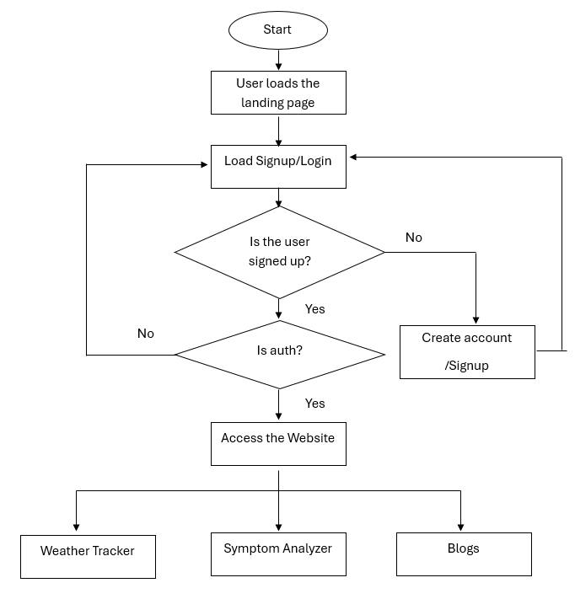

Figure 3.3.1: Flowchart for Atmost Alert

11

**3.4 Mini Project Contribution :-**

1. Shweta Shimpi: Developed the user interactive sections

Managing all the databases required

1. Ninad Walke: Creating the framework of the website

Developing the all the backend of the website

1. Aarya Walve: Styling the website

Documentation

PPT

12

**3.5 Experimental Results :-**

1. Landing – Home Page:

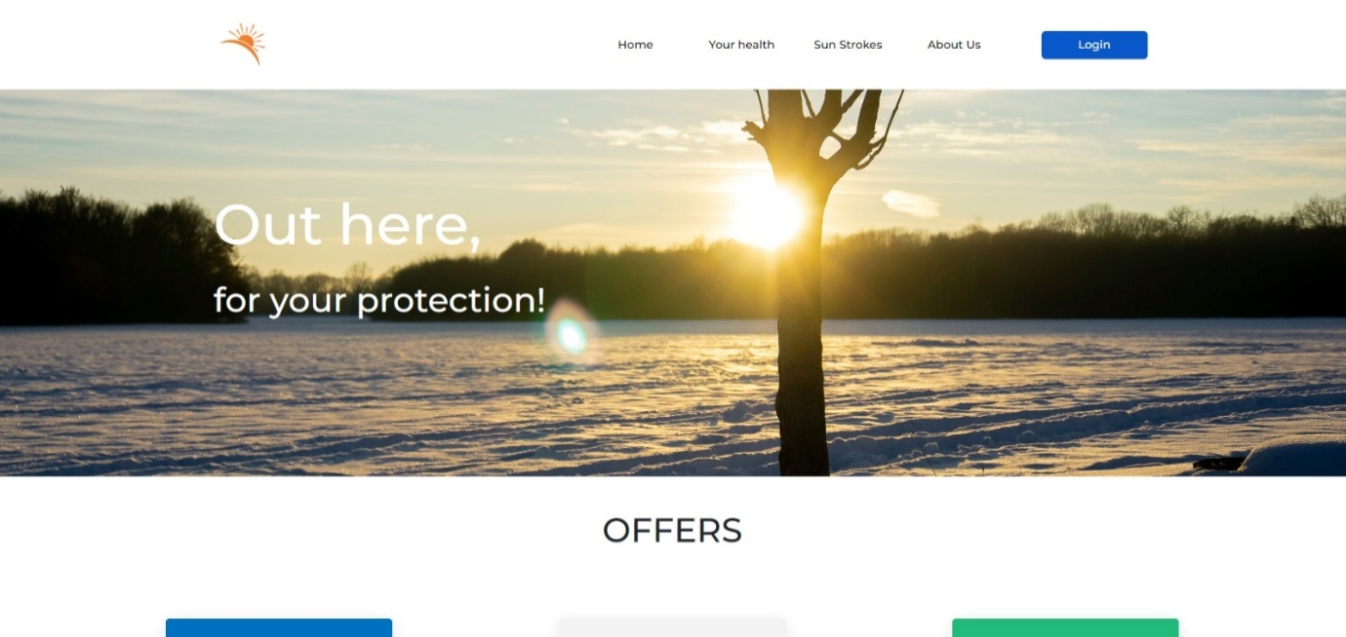

3.5.1 Landing – Home

1. Landing – Health:

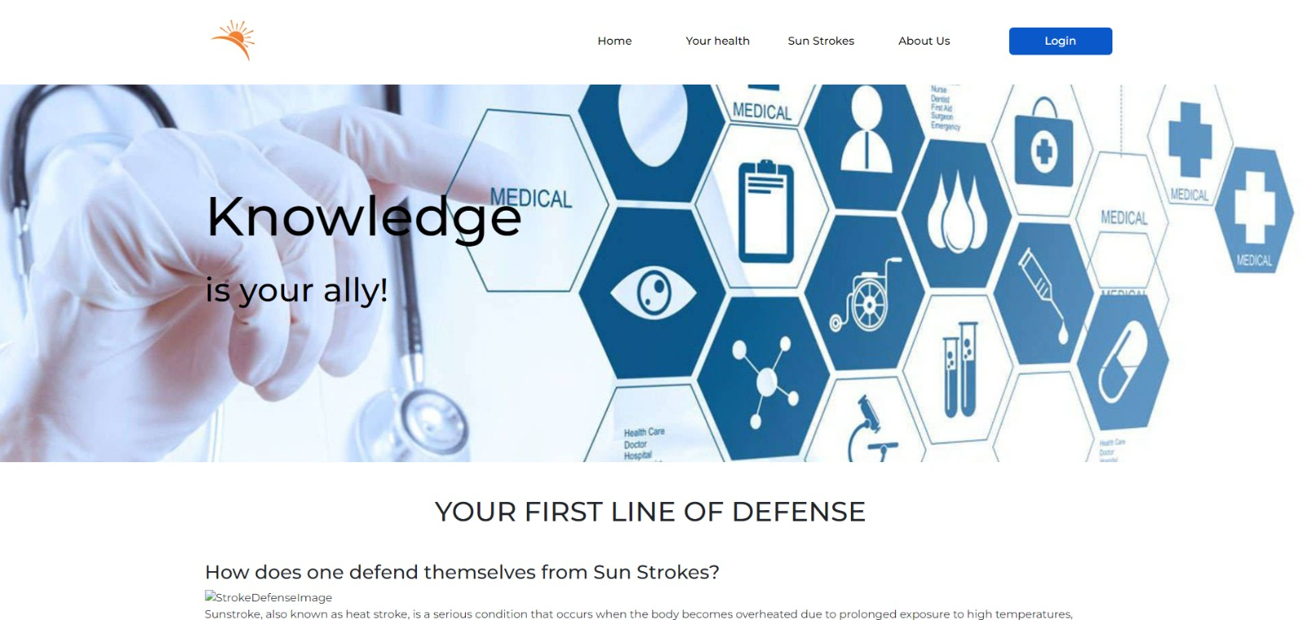

3.5.2 Landing – Health

13

1. Landing – Strokes:

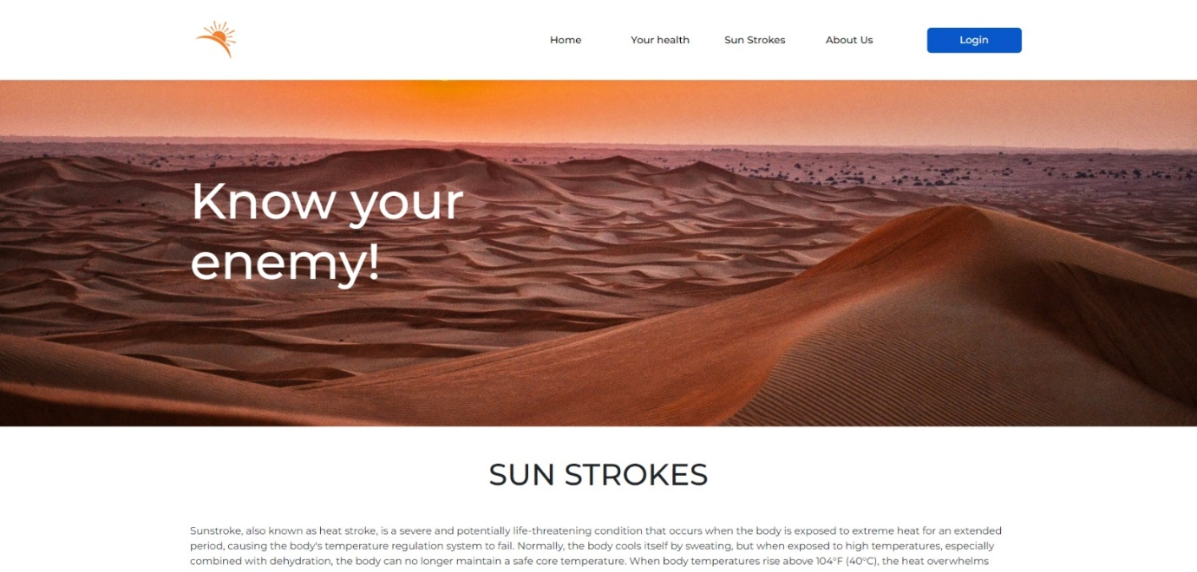

3.5.3 Landing - Strokes

1. Landing – About Us:

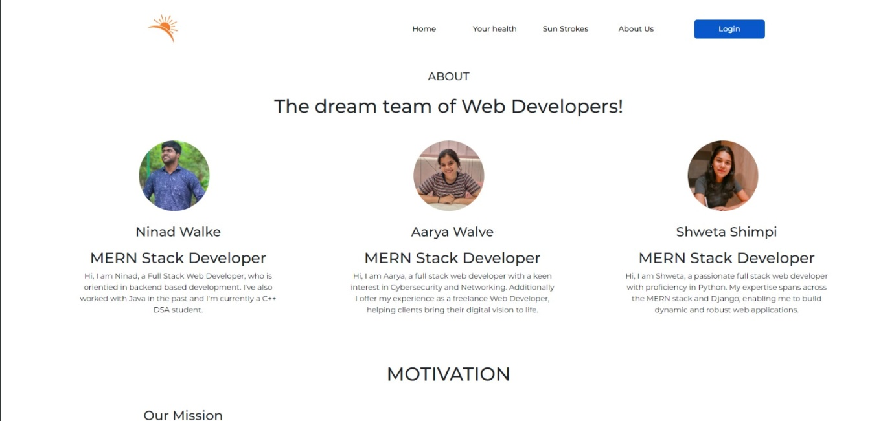

3.5.4 Landing – About Us

14

1. Login:

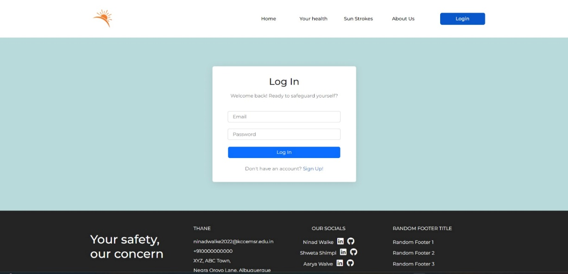

3.5.5 Login

1. Sign Up:

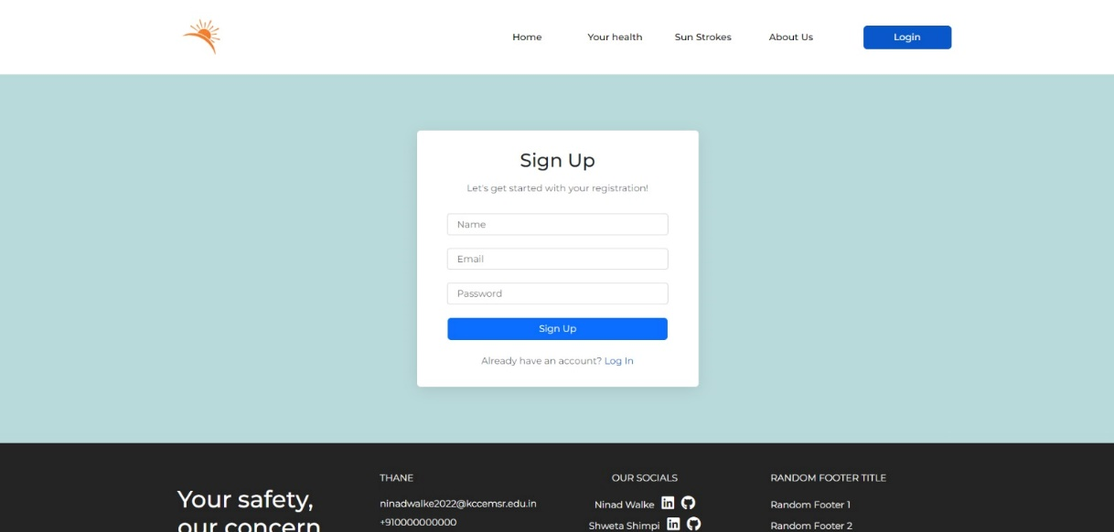

3.5.6 Sign Up

1. Dashboard – Home:

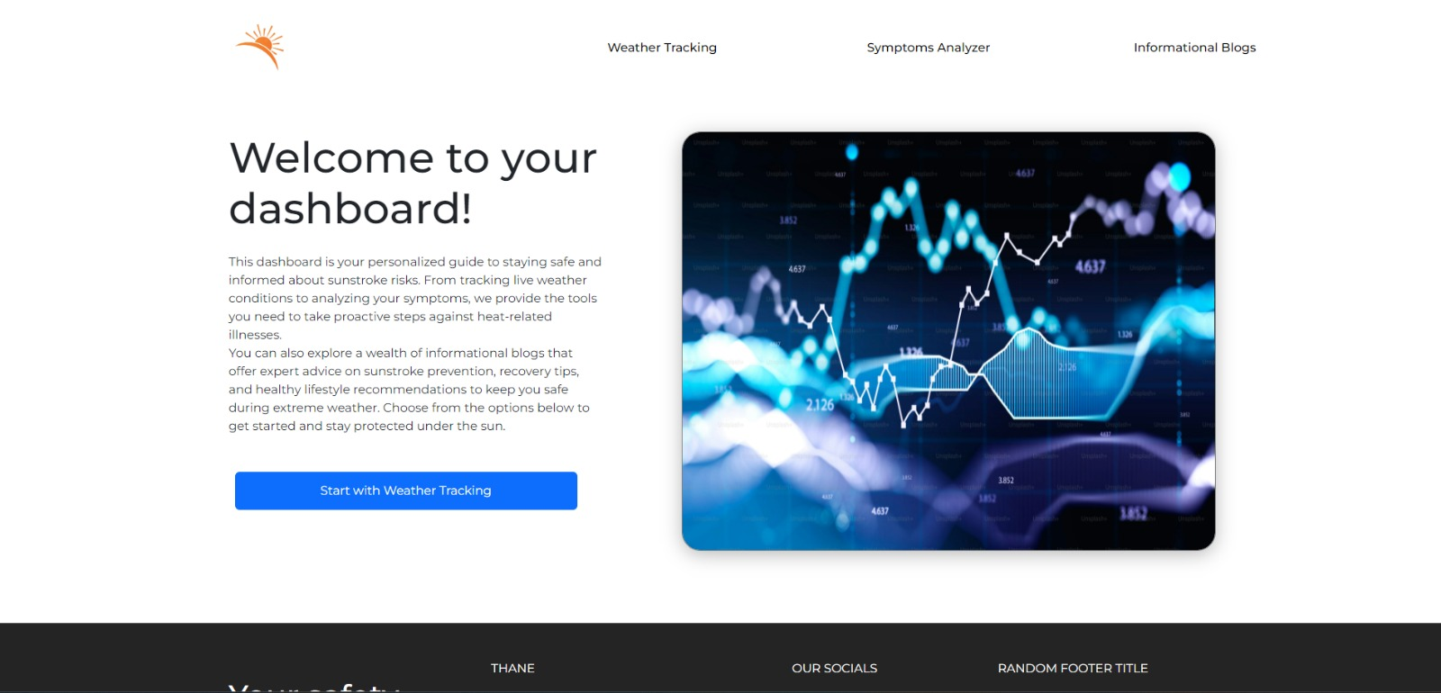

3.5.7 Dashboard – Home

1. Dashboard – Weather Tracker:

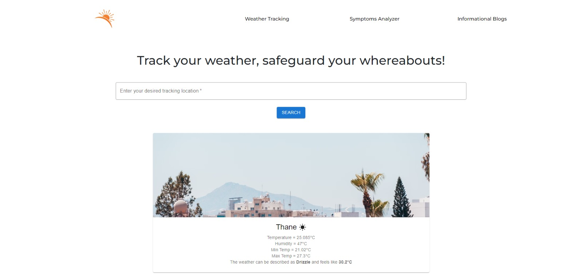

3.5.8 Dashboard – Weather Tracker

1. Dashboard – Symptom Analyser:

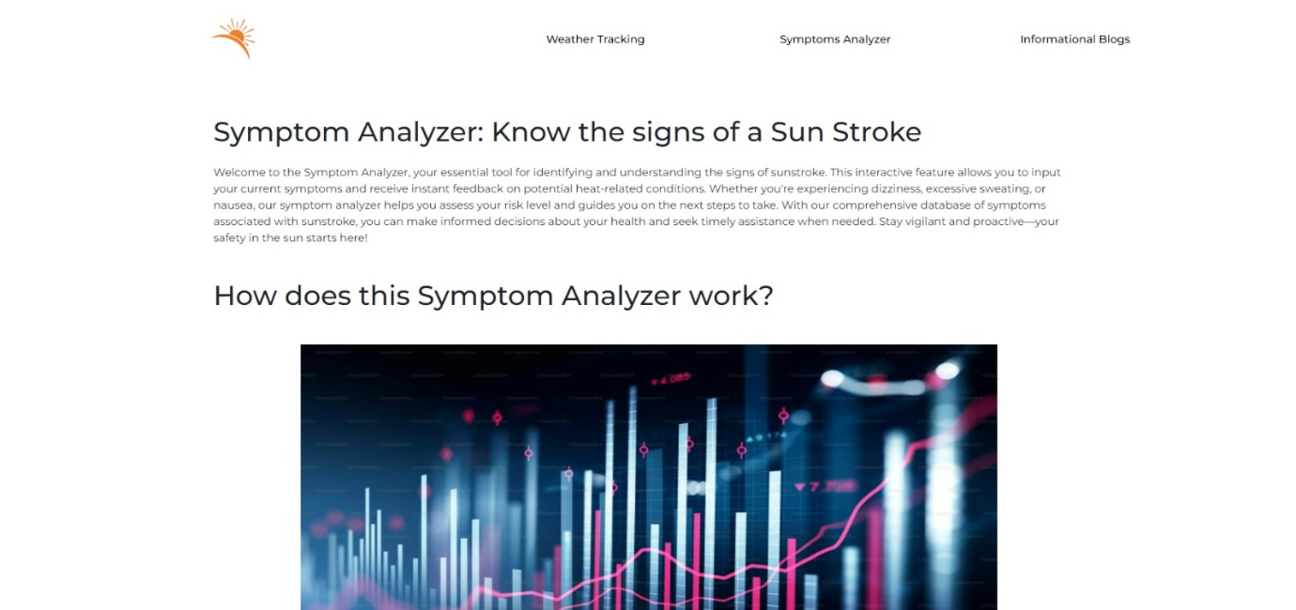

3.5.9 Dashboard - Symptom Analyser

16

**4.Conclusion and Future Scope**

**Conclusion: -**

In conclusion**,** AtmosAlert has emerged as a comprehensive solution for mitigating the growing health risks associated with extreme heat. By combining real-time weather data, personalized health assessments, and preventive measures, the platform empowers individuals to make informed decisions and protect themselves from sunstroke and other heat-related illnesses.The architecture of AtmosAlert, featuring React.js, Node.js, Express.js, and MongoDB, ensures scalability, flexibility, and performance. This robust foundation enables the platform to handle increasing user loads, adapt to evolving needs, and deliver efficient services.While AtmosAlert has achieved significant success, there is ample room for further development. Exploring the integration of machine learning algorithms for more personalized recommendations, implementing offline functionality, and enhancing accessibility can further elevate the platform's value.In conclusion, AtmosAlert represents a promising approach to addressing the global challenge of heat-related health risks. By providing accessible, user-friendly resources and leveraging cutting-edge technology, the platform has the potential to make a significant impact on public health and well-being.

**Future Scope: -**

AtmosAlert, as a digital platform designed to mitigate the risks of sunstroke and heat-related illnesses, has significant potential for future development and expansion. Here are some key areas for exploration:

1. **Enhanced Personalization:** Utilize machine learning algorithms to analyze user data, including symptom history, preferences, and location, to provide even more tailored recommendations and alerts.
2. **Emergency Contact Integration:** Allow users to link their emergency contacts to the app, enabling quick and easy communication in case of a heat-related emergency.
3. **Integration with Wearable Devices:** Develop compatibility with wearable devices (e.g., smartwatches) to provide real-time health monitoring and alerts directly on the user's wrist.

1. **Smart City Integration:** Integrate AtmosAlert with smart city infrastructure to provide real-time information on heat-related risks, such as urban heat islands, and recommend safe outdoor activities.
2. **Integration with Transportation Apps:** Partner with transportation apps to provide real-time updates on public transportation schedules and routes, helping users avoid exposure to extreme heat during travel.
3. **Partnerships with Academic Institutions:** Collaborate with universities and research institutions to conduct studies on heat-related illnesses and develop evidence-based recommendations.
4. **Heat Safety Education:** Incorporate interactive educational modules within the app to provide users with in-depth information about heat-related illnesses, prevention strategies, and first aid techniques.

18

**5.References**

[1] Shivangi Viral Thakker, Jayesh Parab and Shubhankar Kaisare,” Systematic research of E-learning platforms”, Asian Association of Open Universities journal November 2020

[2] Franky Samuel Octavianus, Alexander Hamonangan Simamora,” A Learning and Administration Website for Interns”, Journal for Lesson and Learning Studies September 2023

[3] Maria Bellaniar Ismiati, Latius Hermawan” Online Quiz Application for Informatics and Information SystemStudents”, JCSE (Journal of Computer Science an Engineering) February,2020

[4] Sushant Umesh Tripathi, Prajwal Sawant, Kaynat Momin” Practical apprasddadasaoach to learn Data Structures and Algorithms (DSA) using DSA visualizer” TIJER 10(Issue 4),723-729

[5] D Chavan, A Kiran” Dot Diffusion Block Truncation Coding for Satellite Image Retrieval” International Journal of Computer Applications 124 (4), 24-29

[6] D Chavan, KA Bhandari “A NEW BLOCK TRUNCATION CODING (NBTC) FOR SATELLITE IMAGE RETRIEVAL USING DOT-DIFFUSION” IJSER 6 (ISSN2229-5518), 9

[7] Leni Susanti, Nur Azmi Karim and Yudi Ramdhani “E-learning and sustainable user: the model of academic performance in e-learning” ETMC 2023, Web of conferences 485, 01006

[8] Shuting Chen, Julius Simon “The Influence of e‐learning on Students' Learning Motivation in Jiangsu University” International Journal if Education and Humanities Vol. 12, No. 1, 202

19